**test.txt**

PGO START 2000

beta equ alpha

alpha resw 1

END

**Eclipse console:**

SymbolNotFoundException

Symbol Table content:

Size of the Symbol Table : 2

|Name: PGO |Value: 0 |Tpye: R|

|Name: ALPHA |Value: 2000 |Tpye: R|

end of Symbol Table

**listFile.txt**

line 1|location: 0000| |PGO START 2000

line 2|location: 2000| |BETA EQU ALPHA

line 3|location: 2000| |ALPHA RESW 1

line 4|location: 2003| | END

|

V

**refer to the listFile by using the SIC/XE assembler that teacher give:**

SIC/XE Assembler Version 1.00

Public Domain 1993 by LBL, Keny, Ted

Line Loc ObjCode Source Line

---- ---- -------- -----------------------------

1 2000 HWONE START 2000

2 2000 BETA EQU ALPHA

*** Error 46: Symbol must be defined before used in EQU statement

3 2000 ALPHA RESW 1

4 END

**test.txt**

PGO START 2000

STA AAA

LDA BBB,X

AAA RESW 3

ORG AAA

BBB lda #3

ORG

CCC BYTE X'5A'

DDD WORD 16

END AAA+6

**listFile.txt**

line 1|location: 0000| |PGO START 2000

line 2|location: 2000|0F2003 | STA AAA

line 3|location: 2003|03A000 | LDA BBB,X

line 4|location: 2006| |AAA RESW 3

line 5|location: 200F| | ORG AAA

line 6|location: 2006|010003 |BBB LDA #3

line 7|location: 2009| | ORG

line 8|location: 200F|5A |CCC BYTE X'5A'

line 9|location: 2010|000010 |DDD WORD 16

line 10|location: 2013| | END AAA+6

**objCode.txt**

HPGO 002000000013

T002000060F200303A000

T00200F070100035A000010

E00200C

**OpTable.java (有待確認)**

opTable[3][0][0] = "DIV";

opTable[3][0][1] = "3"; -> 1

opTable[3][0][2] = "24";

opTable[3][1][0] = "DIVF";

opTable[3][1][1] = "3"; -> 1

opTable[3][1][2] = "64";

opTable[5][0][0] = "FIX";

opTable[5][0][1] = "1"; -> 3

opTable[5][0][2] = "C4";

opTable[5][1][0] = "FLOAT";

opTable[5][1][1] = "1"; -> 3

opTable[5][1][2] = "C0";

opTable[7][0][0] = "HIO";

opTable[7][0][1] = "1"; -> 3

opTable[7][0][2] = "F4";

**老師講義：**

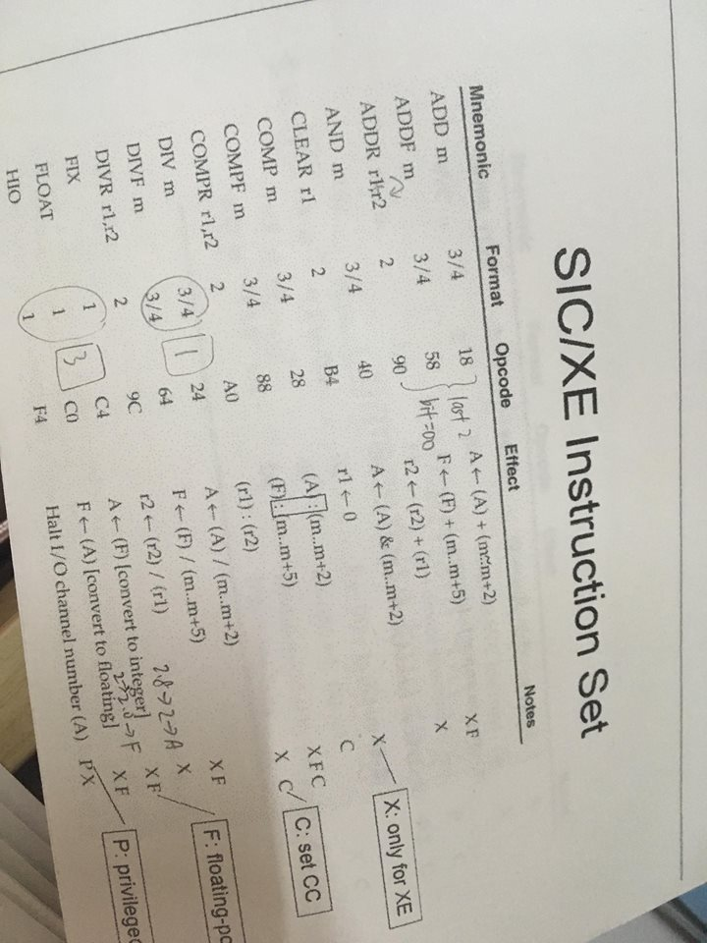

**參考書：**

